In the weightlifting industry, one of the most important pieces of equipment is the power rack. It is a piece of machinery that allows a user to perform several key free weight exercises including bench press, inclined press, declined press, and squats. One of the many challenges of any power rack user is the necessity of a spotter when working out. A spotter is a person whose primary goal is to monitor the weightlifter and assist him or her in case he or she is struggling to lift the weight bar off of his or herself. The downfall to this system is that another person is required to work out. This can be an inconvenience when trying to schedule a work out time due to having to fit into someone else's schedule. Also, a workout partner may have to cancel occasionally, or the gym user in question just may prefer to workout at his or her convenience rather than on a set schedule. Another setback to working out with a spotter is that the workout will take longer. Generally, two people will take turns spotting while the other works out. So half of the time spent in the gym is spent not exercising.

Most people, whether pro athletes or the grocery bagger at the local supermarket, see the need and have a desire to be in shape. The problem that many people face is not enough time to adequately work out on a regular basis. They may not be able to find a spotter. If this occurs, they either give up and don't go work out or they work out anyways. If they decide to go work out, they face a choice of working out as they normally would, putting themselves at risk under a weight bar whose weight is on the edge of their abilities or they can choose to either use a lighter weight or use another machine that does the job less efficiently. These less efficient machine will be discussed in the next paragraph. So obviously an ordinary person is inconvenienced by the need for a spotter because either safety must be sacrificed or the user must resort to a inferior workout, meaning they would need more time to achieve the results they seek. Even someone who has a regular workout partner faces issues because workouts with spotters are twice as long due to the sharing nature of most work out partnerships.

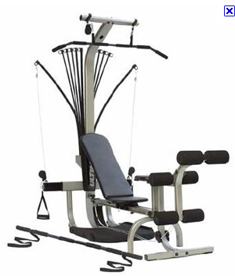The need for a device to solve this dilemma is obvious due to the number of machines already trying to address the problem. The first and probably most well-known is the Bowflex™ machine. It is created by Nautilus and is the leading machine in resistance-based gym equipment. It relies on pulleys and bendable bars to provide resistance to a gym user's movements. The benefits are that the machine is incredibly safe. A user could not injure himself if used properly. There are two main problems with this device. First, the maximum resistance a BowflexTM can provide is 410 lbs. And the common models only provide 210 lbs. For many users, especially professional athletes or power lifters, this is simply not enough. Another downfall is that the resistance provided is dependent on how much the resistance rods are being stretched. The amount of resistance the user is experiencing is minimal near the beginning of one repetition and only reaches its maximum resistance as the user reaches the full extension of the exercise. This results in the majority of the workout not actually using the desired resistance.

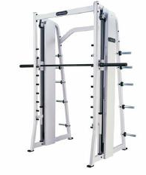Another popular solution on the market is a Smith machine. It looks similar to a normal power rack except there is a vertical steel rod that the weight bar is attached to. This vertical rod is a track upon which the weight bar can freely move up and down but the bar cannot rotate or shift. This provides the user with moderate safety but a user can still be injured if they are not careful and aware of their extreme physical limits. The problem with this machine as well as many other solutions is that it is a constrained environment. This means that the body part being worked out will move in a predetermined constrained path and cannot vary off the path. This results in only a few muscle groups being worked out. All of the smaller muscles that are not needed simply to move from point a to point b are called stabilizer muscles. These stabilizer muscles are not being exercised. This results in the need to do a totally different exercise to work out that muscle group. It may take several exercises to replace one non-constrained exercise.

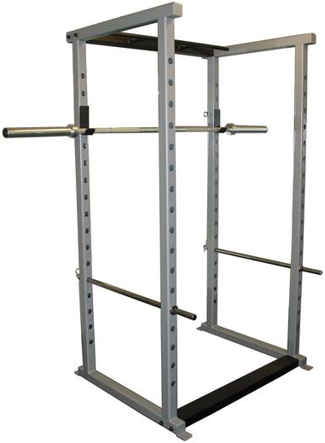 The last illustration to be given is a feature on most power racks called a weight stop. It is a metal bar that attaches to the vertical towers of the power rack and runs parallel to the gym user. It can be adjusted to different heights and is to be placed just higher than the chest when doing press related exercises. When working out if the user cannot continue lifting the weight bar and gives up, or if the bar slips from the user's grip the stop will catch the bar before it hits the user's chest. This provides great safety and is a non-constrained environment. It's also an extremely cheap solution. There are two problems with this solution. According to heelsforhealth.com, when working out, the most muscle building happens at two points, when the bar has reached the users chest and he is lifting it up, and when the user begins to struggle to lift the bar and requires just a few pounds of help to lift the bar up. These two points build a significant amount of muscle compared to the rest of the work out. The problem with the stop is that it limits the range of motion the user has when the bar is near the chest. The weight bar can only go so far down until it hits the stop causing the user to lose crucial muscle building depth. Also when the user begins to struggle under the bar and the bar falls. The user can no longer workout that muscle group without getting up and reducing the weight.

Our solution to the problem seeks to be a non-constrained environment, provide maximum safety, and allow the user to have all the benefits of standard free weight exercising. What our device will do differently from the competition is allow the user to work out as they normally would while monitoring them through sensors and reacting to their work out intelligently using a well developed algorithm to provided adjustable spotting when needed through a motorized apparatus that will lift the bar.

The spotting process of our device can be broken into three main components:

* sensing the location of the weight lifting bar
* the algorithm that determines spotting needs
* the lifting apparatus that shall lift the weight bar

All components have cost as a criterion due to the fact that our solution must be within a permitable cost range of other solutions on the market such as Bowflexes™ and Smith machines . The target cost is $2000.

Sensing the location of the bar requires accuracy of approximately + or - 1 inch. This was chosen because the weight bar is about 2 inches thick at the thicker parts at the end and a tolerance of 1 inch would allow the bar to at least overlap the sensed location of the bar. The sensor system must be able to track the bar without any contact between the bar and the rest of the machine. This is to meet the requirement of being a non-constrained environment. The sensing system must be able to report the height of the bar from a reference point on a parallel plane to the floor. All other variables in the location of the bar are not needed. The sensing system needs to be able to report the location of the bar 100 times a second. this is because if the bar slips and begins to fall towards the user it will fall at a rate of 9.8m/s2. 100th of a second would not result in much movement allowing the machine to realize a problem and assist in time to save the user. The sensor system must also be able to uniquely track the bar and nothing else. The environment the bar is in cannot guarantee another object will not be in the vicinity. So the sensing system must be able to differentiate from the bar and other objects.

As the bar is being monitored, the data containing its location must be sent to the microprocessor which will then put the data through an algorithm that will decide when and how to administer aid to the user. The microprocessor needs to be able to keep up with the incoming data, so the speed of the microprocessor needs to be several orders of time faster than the incoming data so that it can perform calculations in between receiving the data. The algorithm created must be able to look at the data and calculate the speed that the bar is moving. the algorithm must be able to determine when a user is in need of aid. This shall require extensive research. The algorithm must be able to control the lifting apparatus in a way that it can adjust movement speed of the apparatus as well as lifting power provided.

The lifting apparatus must be controllable from the microcontroller in a way that its speed and lifting power may be varied. The lifting apparatus must be able to support 2000 lbs of impact force from the weight bar. The lifting apparatus must be moderately quite due to its proximity to a user. A goal of less than 50db from the location of the top of the bench where a user’s head would rest should be achieved. This is the volume of normal conversation at about 2 feet away. This volume was chosen as to not startle or be a nuisance to the user. The apparatus must be able to operate off of normal wall voltage and current.  
The following table is a decision matrix used to decide what options to go with for the sensing system, microcontroller, and lifting apparatus. Every option is evaluated by 3 criteria. The evaluation is a one to ten scale with a higher number meaning a more desirable option.

The sensing system has three criteria: accuracy, speed, and price. Accuracy is the most important criterion because the whole spotting system is depending on the data provided by the system. The speed of the sensing system is how quickly it can collect the data needed, pass it to the microcontroller, then be ready to collect data again. This speed must be fast enough that the bar moving at a rate of 9.8m/s2 cannot fall more than the required accuracy of the sensor which is 1inch. This way the sampled data is as accurate at the sensor’s analog accuracy. All sensing systems were found to be much faster than needed so speed is not an important criterion. The prices of all the sensing systems were cheap compared to the cost of the whole Dynamis rack, so price is not an important criterion.

The microcontroller has three criteria: speed, price, and familiarity. The speed of a microcontroller is how fast its clock cycle is as well as the clock cycles required for common commands. This speed is similar to the speed of the sensing system but must be several times faster because the microcontroller must be able to receive the data from the sensing system then perform the spotting algorithm before being ready to receive data again. The microcontrollers researched all had speeds at least several orders faster than any sensing system researched making the speed of the microcontroller the least important criterion. The prices of the microcontrollers vary greatly making price an important criterion. Our team’s familiarity with each board is the most important criterion due to it having a large impact on design time. Also our familiarity with different boards varies greatly. Familiarity is the most important criterion.

The lifting apparatus has three criteria: cost, lifting weight, and volume. The cost of the lifting apparatus will comprise a large portion of the cost of the Dynamis system, so cost is the most important criterion. The lifting weight must be enough to meet our requirement of 200lbs. All systems can meet this requirement but some can do much more. Lifting weight is the least important criterion. The volume of the system needs to be kept minimal since the apparatus will be located in a close proximity to the user. The volume must not be a nuisance to the user. The volumes of the different alternatives vary greatly making volume an important criteria.

|  |  |  |  |
| --- | --- | --- | --- |
| *Sensing System* | | | |
| Sensor | Accuracy | Speed | Price |
| Real Time Location System | 1 | 7 | 1 |
| IR Curtain | 6 | 7 | 9 |
| Accelerometer | 4 | 7 | 5 |
| Ultrasonic | 9 | 7 | 4 |
| Theremin Sensor | 9 | 7 | 9 |
| Motion Capture | 10 | 7 | 4 |
| Weight | 80% | 10% | 10% |
| *Microcontroller* | | | |
| Controller | Speed | Price | Familiarity |
| Cerebot | 5 | 8 | 10 |
| Boebot | 10 | 1 | 7 |
| Arduino | 8 | 10 | 1 |
| PIC | 1 | 5 | 1 |
| Weight | 10% | 40% | 50% |
| *Lifting Apparatus* | | | |
| Apparatus | Cost | Lifting Weight | Volume |
| Lead Screw | 4 | 7 | 8 |
| Hydraulic Ram | 3 | 10 | 8 |
| Chain Drive | 6 | 5 | 1 |
| Rack and Pinion Motor Driven System | 1 | 6 | 3 |
| Cable/Pulley | 10 | 5 | 6 |
| Weight | 50% | 10% | 40% |

We will use a combination of an IR curtain and a Theremin Sensor to allow for a differentiation between the weight bar and other obstacles. We shall use a Cerebot board for the microprocessor and a cable and pulley system for the lifting apparatus. This decision was made by multiplying the weights of each criteria the values given to each choice. Every choice’s values were added up for each category and the choice with the highest value was chosen. The two highest valued sensor systems were chosen in conjunction with each other to allow for a secondary system to help negotiate multiple objects being sensed within the vicinity of the bar.